**Task-1:**

Create a bar chart that illustrates total sales versus category, with automatic highlighting of the highest and lowest categories. This chart offers dynamic filtering options based on the last 30, 60, or 90 days, to be incorporated into the report.



**Task-2:**

Implement a custom date range filter with options for filtering data based on time periods such as the last 7, 28, 90, and 365 days, month-to-date, previous month, year-to-date, life-time and previous year.



**Task-3:**

Sales Summary Report: The sales summary report comprises two key components. The first card showcases the total sales, total orders, and average quantity. The second card highlights the total sales, previous sales, and the percentage variance between them.

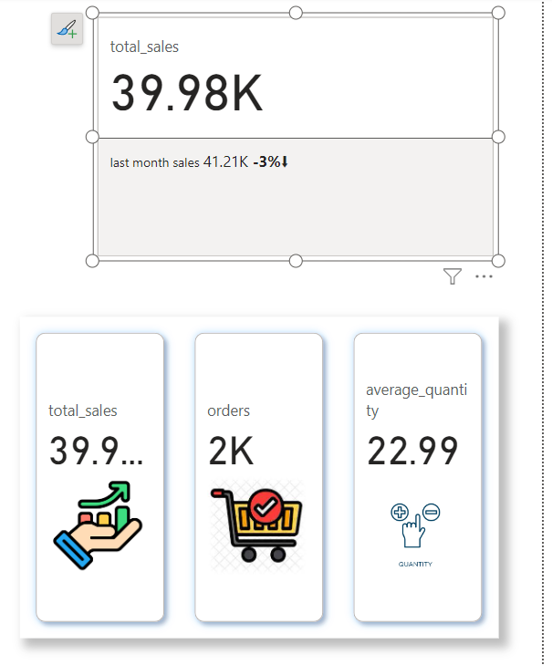

**Task-4:**

Allow the user to modify the target and highlight values exceeding the target in green, and those falling below in grey, on a bar chart displaying sales across different months and years. This feature will be incorporated into a report.



**Task-5:**

Include a lollipop chart illustrating total sales categorized by category, as well as a dumbbell chart showcasing total sales alongside previous month sales on either side. These visualizations will be integrated into the report.  
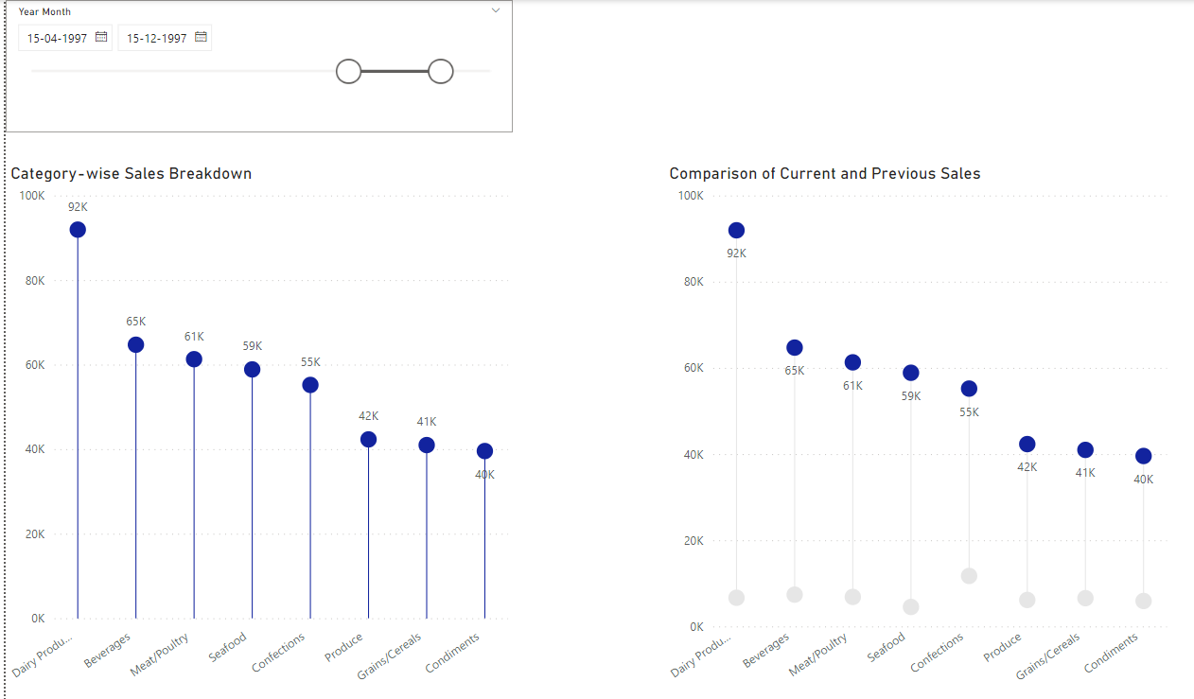  
  
  
  
**Task-6:**

Enable users to adjust the target and highlight products that have surpassed the target sales in a report.



**Task-7:**

Include a variance chart in the report, displaying sales and the percentage of variance compared to the previous month. Positive variances will be highlighted in green, while negative variances will be highlighted in red.

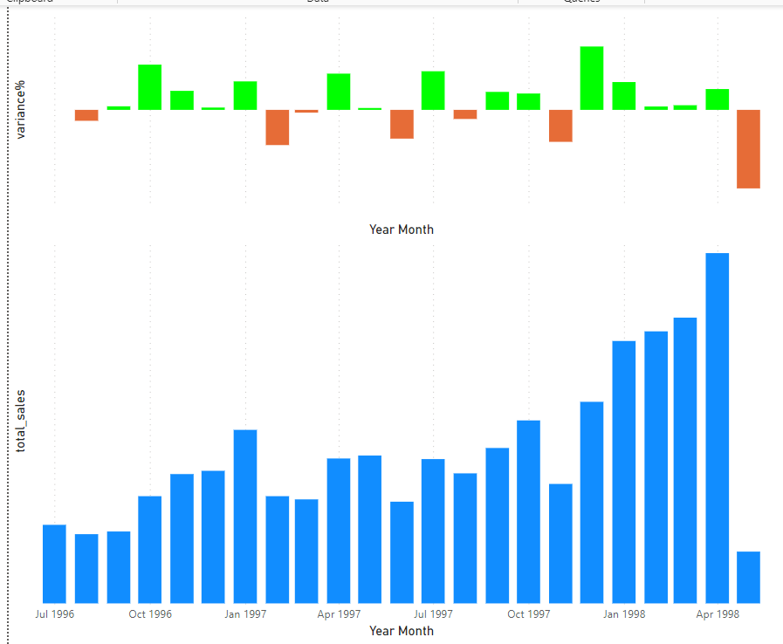

**Task-8:**

Allow users the ability to change the measures and parameters for slicing the measures in the report.



**Task-9:**

Allow users to toggle between displaying the top or bottom N values and provide the option to modify the ranking criteria within the report.



**Task-10:**

Provide users with the capability to modify the target and display the variance between the target and sales slicing by category using a progress bar.



**Task-11:**

Include a Pareto chart in the report, illustrating the percentage of sales versus categories.

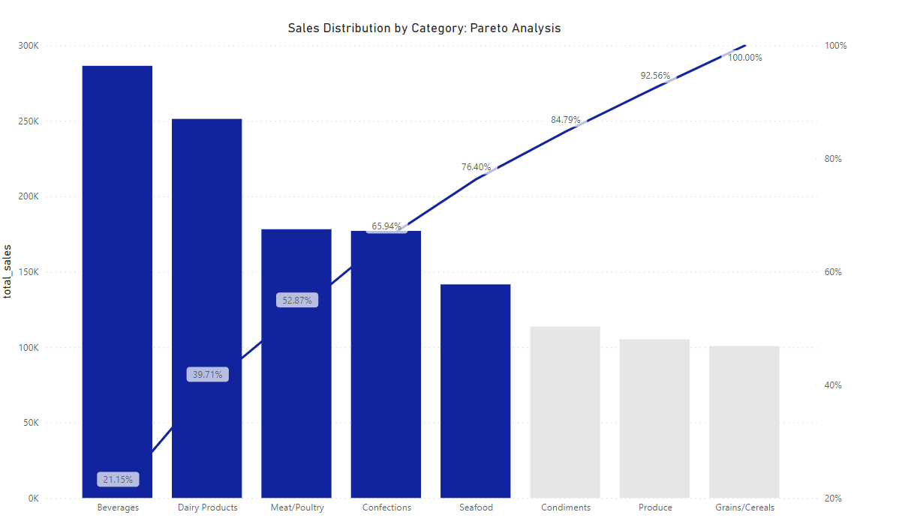

**Task-12:**

Include a quadrant chart in the report, depicting net revenue on the x-axis and gross revenue on the y-axis, divided into four quadrants, with products categorized accordingly.

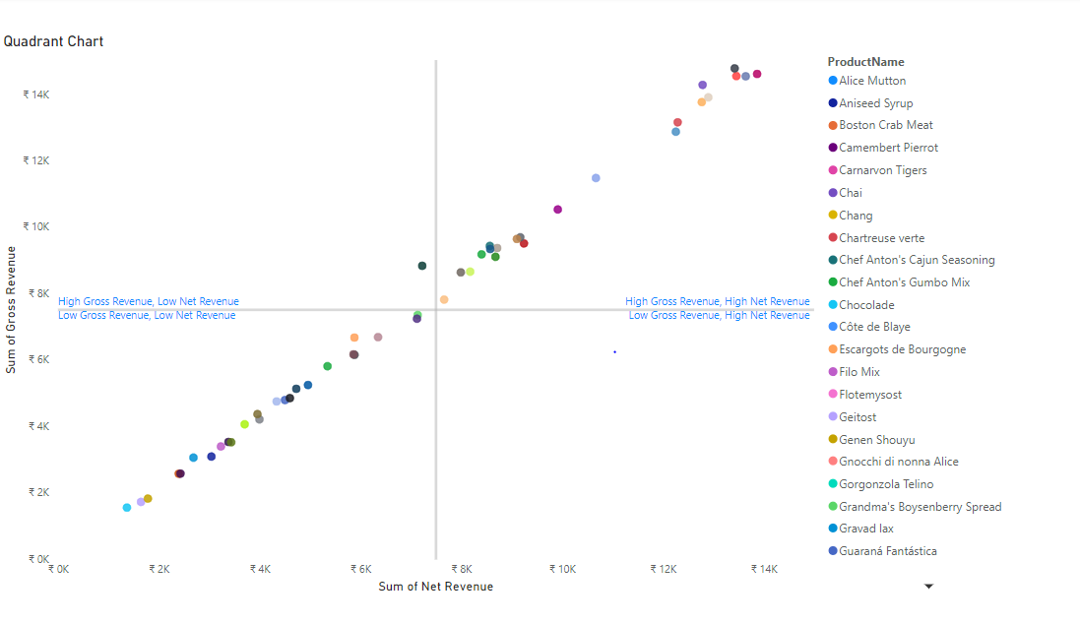

**Task-13:**

Built a dashboard that helps the company to gain valuable insights for business decision making.

